Hi, Ivar,

Thanks very much for your response.
After I encountered this problem, I found the data extracted from contour in the Result in the COMSOL using “export”. I have no ideas why the data jump back and forth. Afterward, I order the data and do the similar geometry again, but it fails again.

Solid interpolation curve

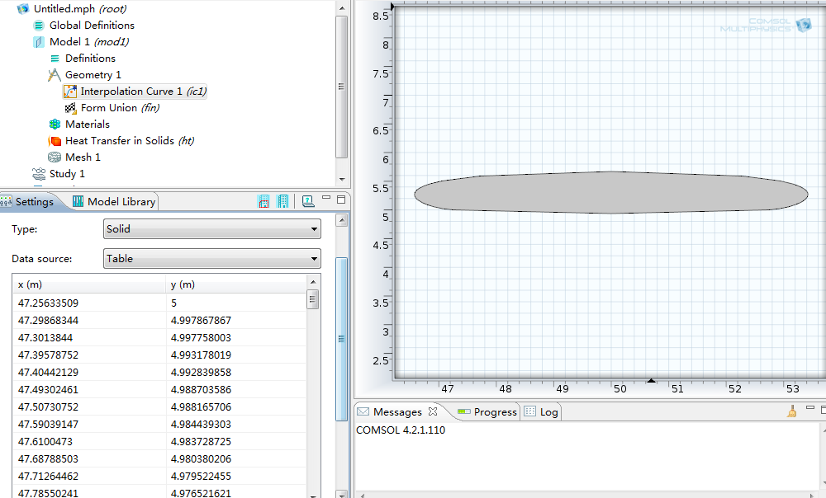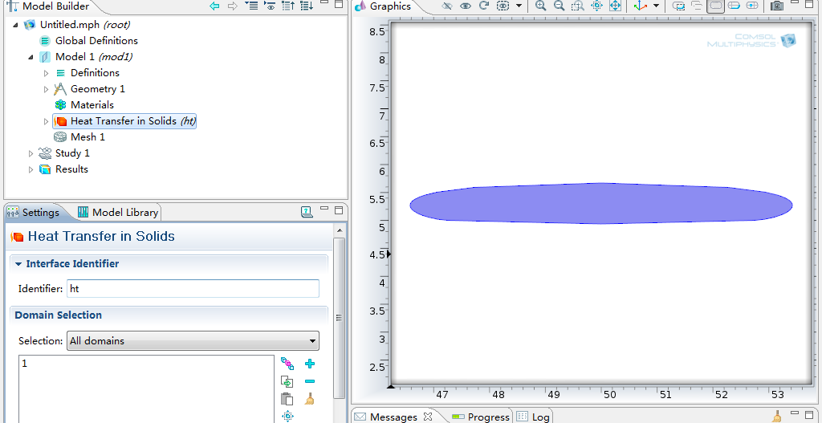
Ordered data
In the Geometry node
In the Physics node
Fig. 1 Ordered data & solid interpolation curve

The open interpolation curve is strange, and the result is a straight line instead of a curve, just in Fig. 2 shown.

Is there something I missed or misunderstood?
Thanks for your response and guidance.
Best wishes to you and your family.

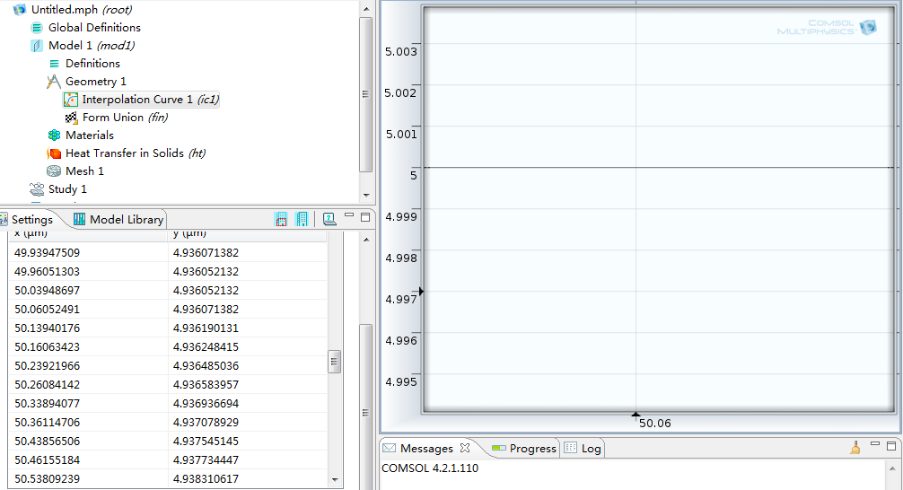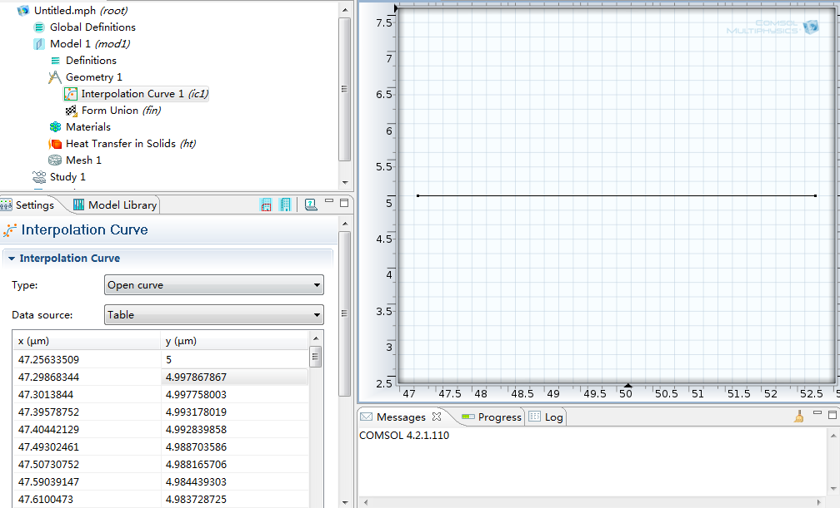
Enlarge
Ordered data
The data should be near 4.93607, so something wrong?
Fig. 1 Ordered data & open interpolation curve

