Question about thermal diffusivity using the temperature-dependent matterial properties

Hi everyone,
I'm building a model based on the "heat transfer module" and "moving boundary (ale) module", while there is something wrong. Could you give me some tips and suggest.

A traditional thermal diffusivity (D=k/rho/Cp) is defined, while there is some puzzle.

The first method:
It is defined as an analytic function "DTS", but it fails due to the "unknown function or operator" (in Fig.1).

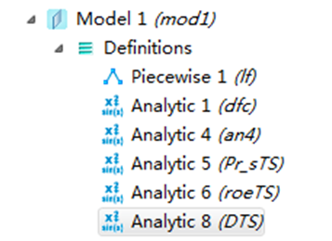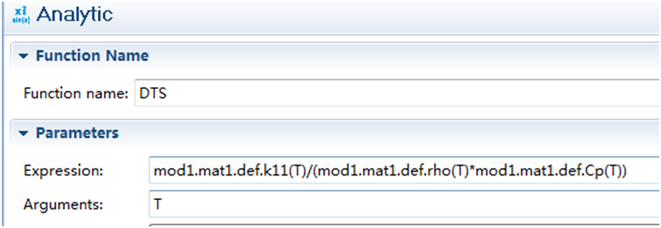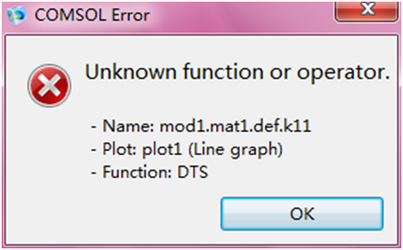
Fig. 1 thermal diffusivity -analytic function plot
3.
error:when plot
2.
expression:
1.
definition:

The second method:

I build a variable in the Global Definitions with the name of "D", just shown in the Fig. 3. Then I define an analytic function D*T for the purpose to plot and check it is right or wrong. Unfortunately, it fails.
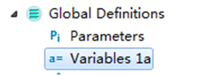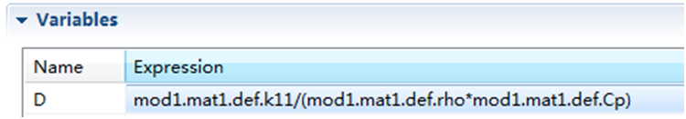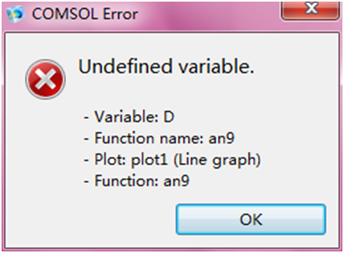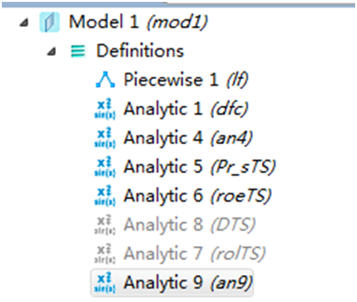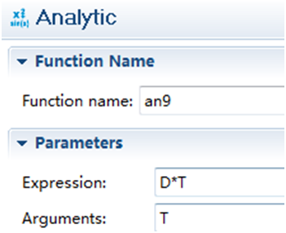
Fig. 2 the second method using global definition
definition:
expression::
plot:
expression::
definition:

Which is the best and right way to build a quantity to present the thermal diffusivity?
In my idea, the second one is right, but if I define another analytic function or something which cites this kind of material properties, just like the Fig.2 illustrated. Can't this kind of functions which using the temperature-dependent material properties plot?

Thanks sincerely in advance.
Best wishes to you and your family.
Yours
FM Huang

