Hi, everyone,

I’m using the “heat transfer” module to construct my model. Traditionally, the ”Initial Value” node is only set into a constant value, usually 295.13 [K] or 300 [K]. I want to set the ”Initial Value” node into a function (external matlab function with the aid of Matlab or an analytic one in COMSOL), which means the initial temperature in the geometrical area is a function relative to the location(x, y).

For example, the initial temperature is a function and can be expressed as “293.15*x^2”, I defined a analytic function “an3= x^2”, so the expression in the initial value (temperature) tablet is set as “293.15[K]*an3(x[1/m])”. All are illustrated in Fig. 1, but it doesn’t work.
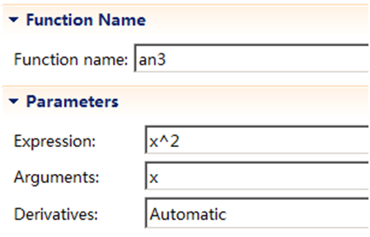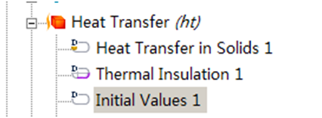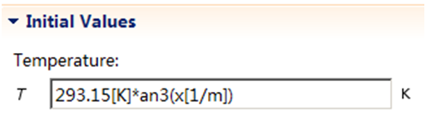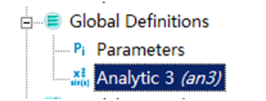
Fig. 1 the detailed operations

Is there anyone can give me some tips and guidance? Could the “Initial Value” node finish (fulfill) this task?
(p.s. franking speaking, the example is simple, so there is no need to build an analytic function in global definitions)

Thanks sincerely in advance.
Best wishes to you and your family.

FM Huang
Dec. 4th.2011

