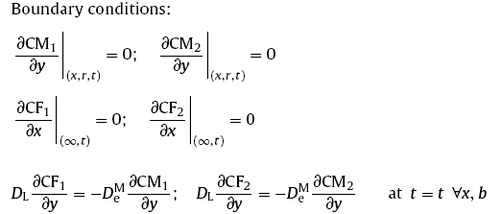

Matrix (Domain1)
Fracture (Domain2)

