Fig 1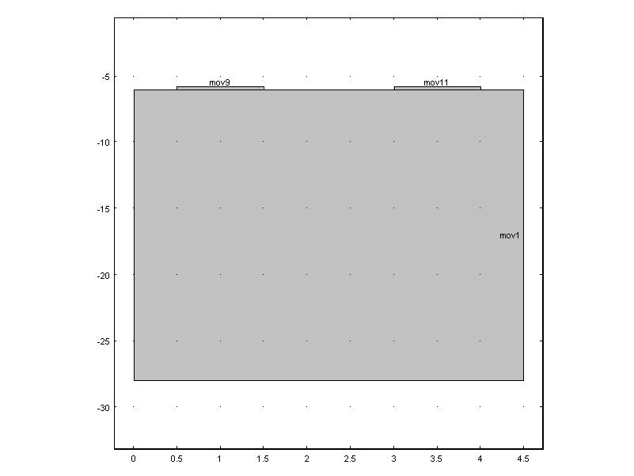
Fig 1 shows the geometry with tow electrodes and the piezoelectric substrate
Electrodes (Al): width (1um) height (0.2um)
Lithium Niobate: width (4.5um) height (22um)
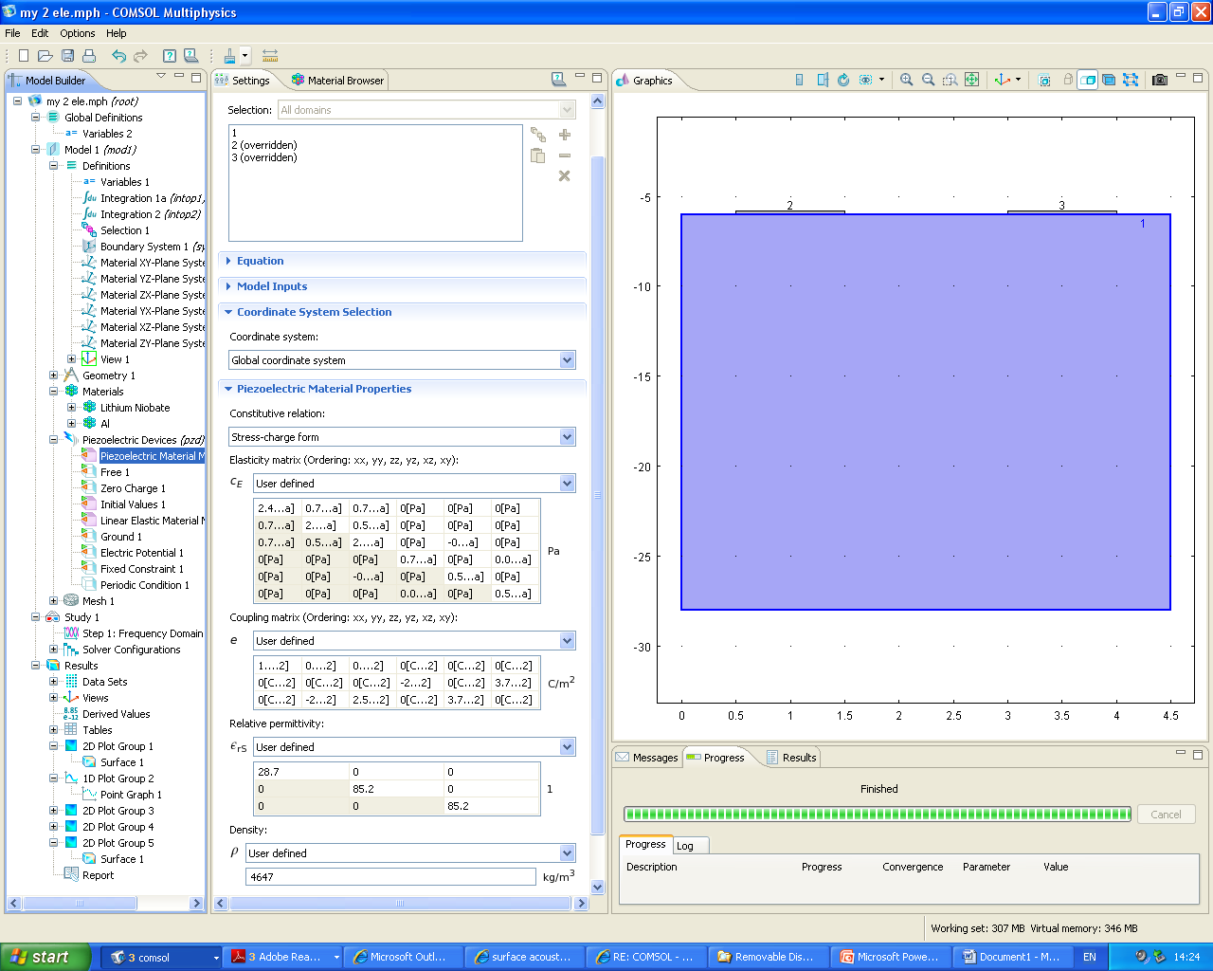
Fig 2
The image in fig 2 shows the conditions for lithium niobate as a Y-Z cut piezoelectric substrate. Please check the values that I have mentioned for Elasticity Matrix, Coupling Matrix, Relative permittivity and density.
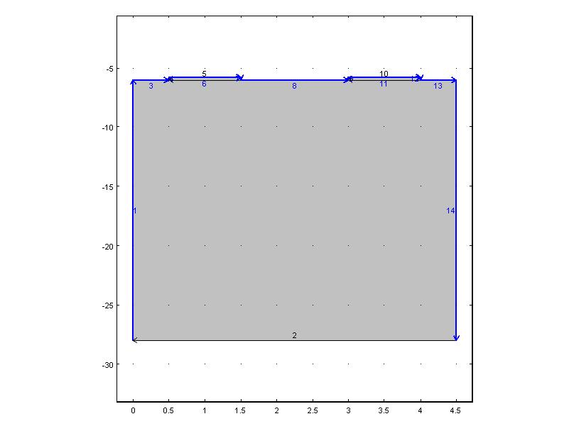
Fig 3: free
I have set the boundary condition as free.

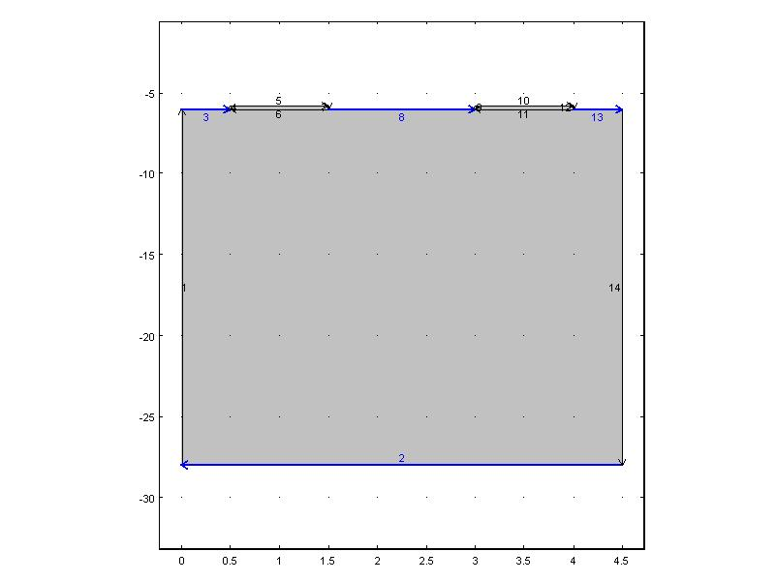
Fig 4: Zero Charge condition

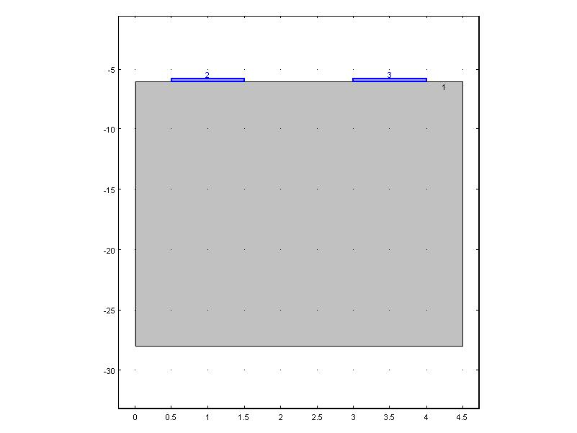
Fig 5: Linear Elastic model(LEM):
I have set two electrode domains as the LEM.
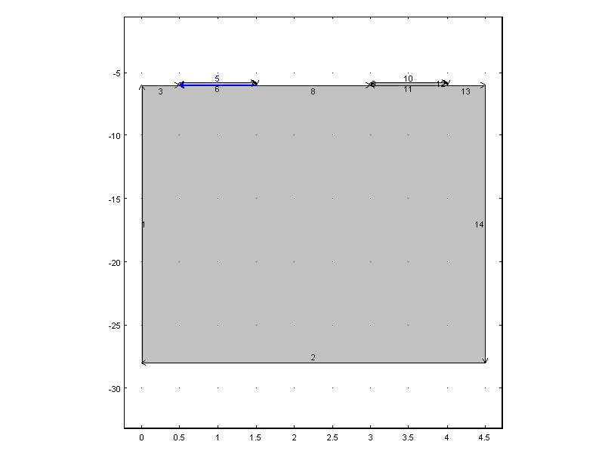
Fig 6:
Set Electric potential as 1V.
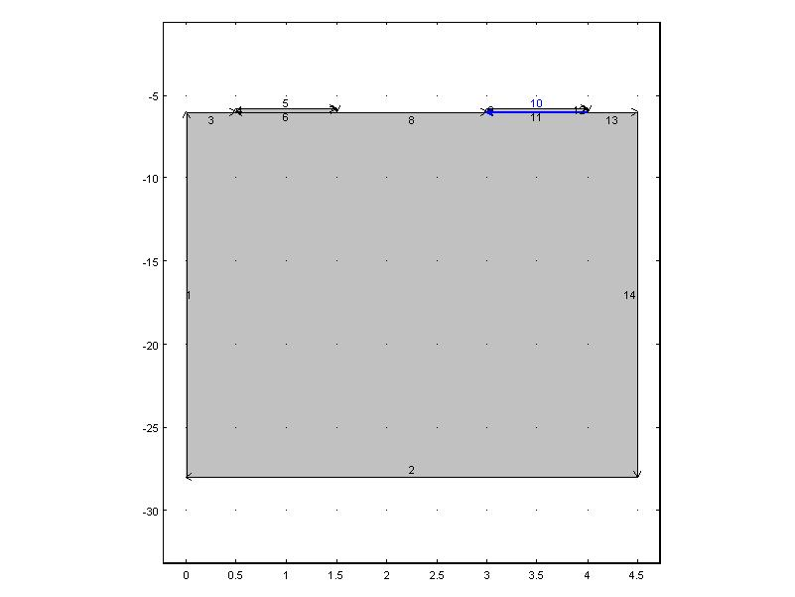
Fig 7:Ground

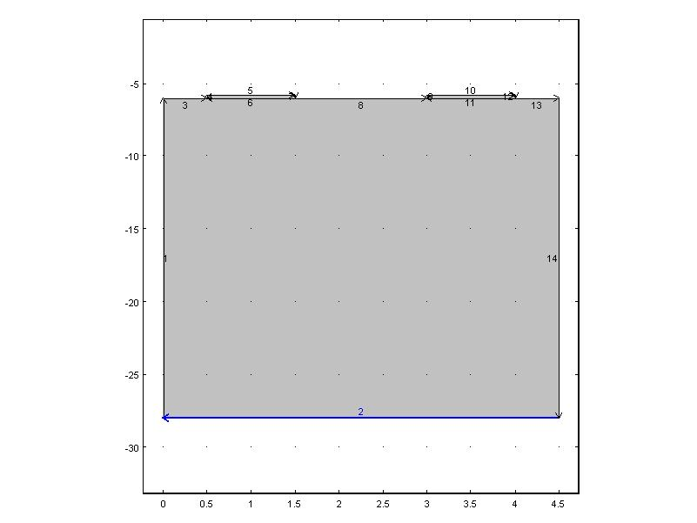
Fig 8: Fixed Constraint
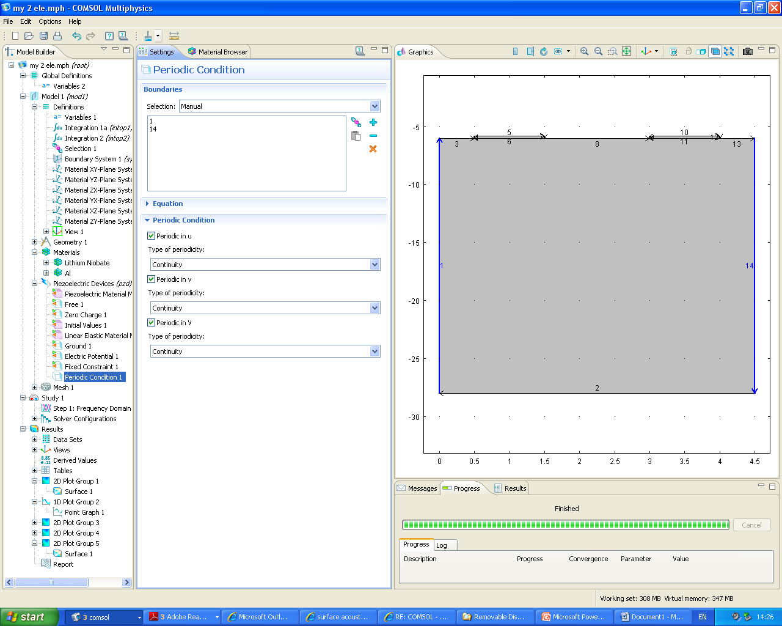
Fig 9: Periodic boundary condition
With u, v, V are on continuous.

Fig 10 Y displacement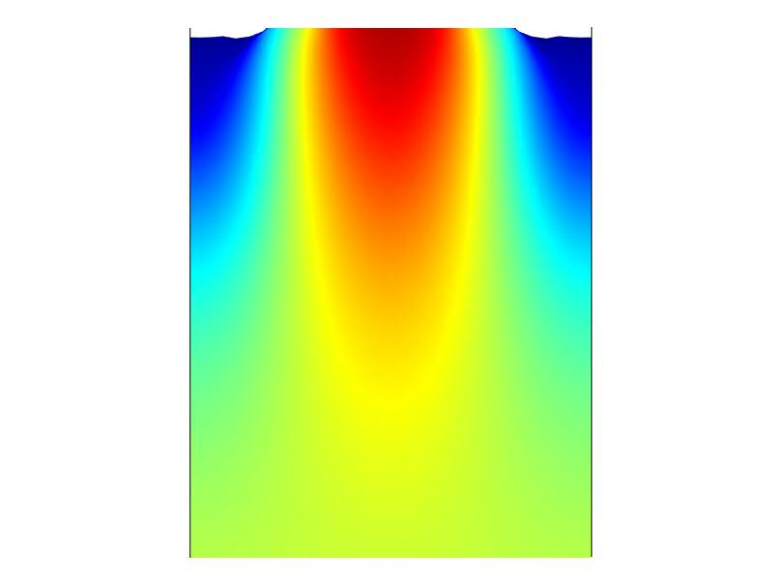
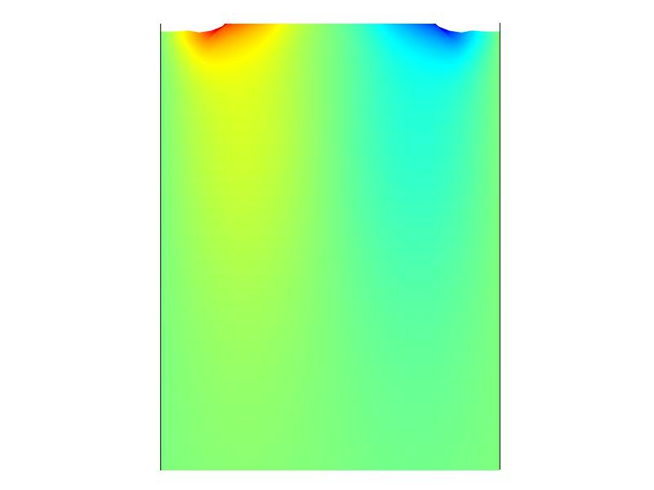
Fig 11 X displacement

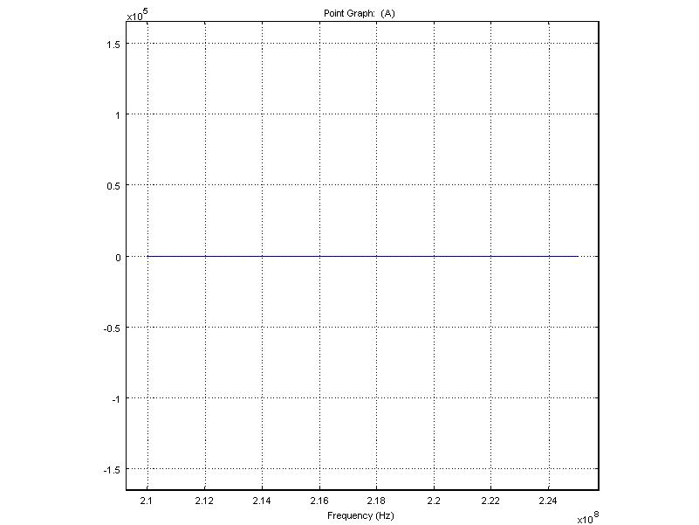
I have plotted Current and frequency at one of the electrode as shown in the above graph.
I have used current equation as: Pzd.nJ* 1e-6[m]

